REPORT FOR SEMINAR

ON

STEGANOGRAPHY

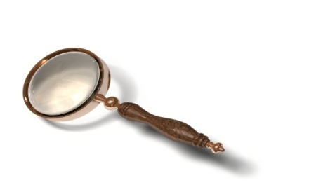

**SUBMITTED TO: SUBMITTED BY:**

**Dr. Sona Malhotra Swati Goel**

**(H.O.D. in CSE deptt) 2511747**

**M.tech 2nd sem, CE**

**DEPARTMENT OF COMPUTER ENGINEERING**

University Institute of Engg & Tech, Kurukshetra**.**

**INDEX**

**1. What is Steganography……………………………………………1**

**2. Steganography vs Cryptography....................................................3**

**3. Steganography vs Watermarking....................................................5**

## 4. Evolution of Steganography............................................................6

### 5. Types of Stagenography.............................................................7

### 6. Steganography-modern day......................................................9

**7. How does it work..................................................................10**

**8. Steganography Examples..............................................................12**

**9. Principles....................................................................14**

**10. Types of steganography................................................15**

**11. Modern Steganography Techniques.............................17**

**11.1 LSB Insertion........................................18**

**11.2 Masking and Filtering..........................20**

**12. Steganography Tools...............................................22**

**13. Applications of Steganography..................................23**

**14. Advantages of Steganography..................................24**

**15. Disadvantage of Steganography..................................24**

**16. Conclusion..................................25**

**List of Figures**

**Fig 1.1** **Steganography Process...................9**

**Fig 1.2** **Working..................11**